**SQL ASSIGNMENT 9**

Q1. Write an SQL query to show the top n (say 10) records of a table.

**Solution:**

Step-1. Select top 10 * from worker

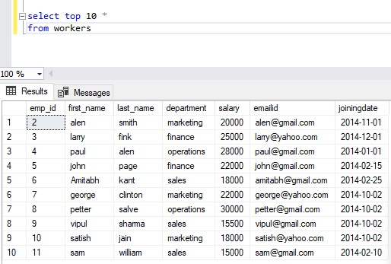

Q2. Write an SQL query to determine the nth (say n=5) highest salary from a table.

**Solution:**

Step-2. Select MAX(Salary) as ‘Fifth-high-salary’ from worker where salary NOT IN ( select DISTINCT top 4 salary from worker order by salary desc);

